RAFFLES INSTITUTION H2 CHEMISTRY PRELIMINARY EXAMINATION 2010 ANSWERS

Paper 3 Answers

Question 1
(a)(i) 2Cd(s) + O₂(g) + 2H₂O(l) → 2Cd(OH)₂(s)
E^{θ}_{cell} = +0.40 – (–0.81) = +1.21 V

(a)(ii) This is to flush out any gases that may participate in the redox reaction.

(a)(iii) Assume pV = nRT. Since n and R are constant, pV/T is constant.
Therefore, (4x10)/288 = (1xV)/298. V = 41.4 dm³

(a)(iv) No, as the carbon atom in methane is in its lowest oxidation state and cannot be further reduced.

(a)(v) 1.15 = 1.21 – 0.0148 lg (1/[O₂])
[O₂] = 8.83 x 10^{–5} mol dm^{–3}

(b)(i) AgCl(s) + e– → Ag + Cl –
Ag⁺ + e– → Ag
Overall equation: Ag⁺(aq) + Cl –(aq) → AgCl(s)
E^{θ}_{cell} = 0.80 – 0.22 = +0.58 V

(b)(ii) At equilibrium, E = 0 V
0 = E^{θ}_{cell} − (RT/nF) ln(1/[Ag⁺][Cl–]) (Note: [AgCl(s)] is a constant)
Therefore, 0 = +0.58 – (8.31)(298)/(1)(96500) ln (1/K_{sp} )
K_{sp} = 1.53 x 10^{–10} mol² dm^{–6}

(c)(i) The electronic configuration of Mn is [Ar]3d⁵4s². As the 3d and 4s electrons have similar energies, successive ionization energies increase gradually. Hence, a variable number of electrons can be removed/a variable number of electrons can be used for bond formation.

(c)(ii) In the presence of ligands, the original degenerate 3d orbitals split into two different energy levels. Since the 3d subshell is partially filled, the electrons in the lower energy 3d orbitals can absorb a photon of energy from the visible light range to promote to the higher energy 3d orbitals. The observed colour is complementary to the wavelength absorbed.

(c)(iii) MnO₄– + e– MnO₄^{2–} E^{θ} = +0.56 V
MnO₄²⁻ + 4H⁺ + 2e– MnO₂ + 2H₂O E○ = +2.26 V

3MnO₄^{2–} + 4H⁺ → MnO₂ + 2MnO₄– + 2H₂O, E^{θ}_{cell} = 2.26 – 0.56 = +1.76V
MnO₄^{2–} can disproportionate in the presence of acid (or give equation above) since the overall cell potential is positive.
In the presence of acid, a green solution of MnO₄^{2–} disproportionate to give a purple solution and a brown precipitate.

(c)(iv)
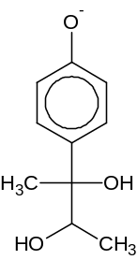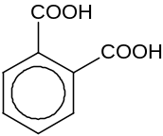

Question 2
(a)(i) Phenol / Phenoxide
NaOH is used to generate the phenoxide which is a better nucleophile than phenol.

(a)(ii) CH₃CH₂COOCOCH(CH₃)₂
_
(b)(i) CH₃COCHCOOCH₂CH₃ The ethoxide ions act as base / remove H⁺.

(b)(ii) Test: Warm both compounds with separate samples of aqueous iodine in aqueous NaOH.
Observation: A yellow precipitate is formed for butanone but not for butan-1-ol.
CH₃COCH₂CH₃ + 3I₂ + 4OH^{-–} → CHI₃ + CH₃CH₂COO– + 3I – + 3H₂O

Other possible tests: 2,4-DNPH, PCl₅, Na(s), KMnO₄ with H₂SO₄(aq) and heat, K₂Cr₂O₇ with H₂SO₄(aq) and heat

(c)(i) Nucleophilic addition

(c)(ii) Geometric isomerism
CH₃
CH₃
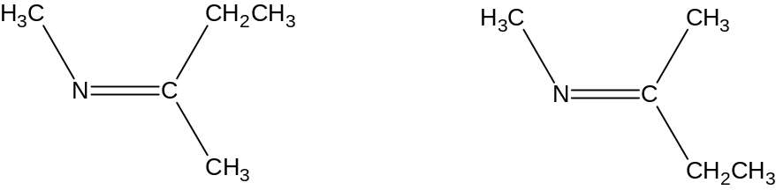

(d)(i) Comparing Expt 1 and 2, when [CH₃CH=CHCH₂Cl] doubles, rate doubles. Hence order of reaction with respect to CH₃CH=CHCH₂Cl is 1.
Comparing Expt 1 and 3, when [CH₃CH=CHCH₂Cl] is tripled, rate should triple. When [OH–] is tripled, there is no further change to the rate. Hence order of reaction with respect to OH– is 0.
Hence, mechanism is nucleophilic substitution (S_{N}1).

(d)(ii)
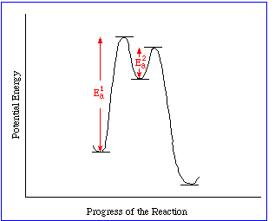

(d)(iii) The p-orbital of chlorine overlaps with the pi-electron cloud of the double bond or there is partial double character between C and Cl

Question 3
(a)(i) The C—F bond is stronger than the C—Cl bond, hence the latter bond is easier to cleave and chlorine radicals are more readily produced.

(a)(ii) O⁺: 1s²2s²2p³ F⁺: 1s²2s²2p⁴
Due to the interelectronic/electron-electron repulsion between the paired p electrons in F⁺, it is easier to remove the electron from F⁺ than O⁺. Hence the second IE is higher for O / lower for F.

(b)(i) Add sodium chloride crystals to concentrated sulfuric acid.
Hydrogen iodide will be further oxidised by sulfuric acid to form iodine.
To produce hydrogen iodide, a non-oxidising acid such as concentrated H₃PO₄ should be used.

(b)(ii) Electrophilic substitution
AlCl₃ + Cl₂ → AlCl₄– + Cl⁺

(b)(iii) Ultraviolet light or strong heating

(b)(iv)
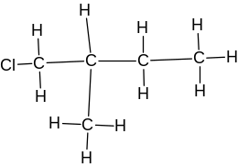 | 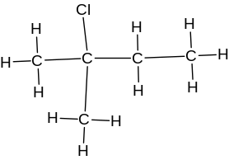 | 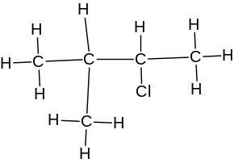 | 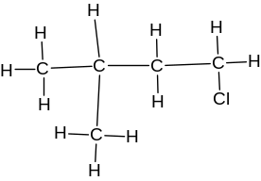
6 x 1 = 6 | 1 x 5 = 5 | 2 x 4 = 8 | 3 x 1 = 3

(c)(i) Disproportionation

(c)(ii) ClO– + 2I– + 2H⁺ → Cl– + H₂O + I ₂

(c)(iii) Amount of thiosulfate = 50/1000 x 0.100 = 5 x10^{–3} mol
I₂ + 2S₂O₃^{2–} → 2I– + S₄O₆^{2–}
Amount of I₂ ≡ 2S₂O₃^{2–} ≡ ClO –
Amount of ClO– = ½ x 5 x10^{–3} = 2.5 x10^{–3}
Concentration of ClO– = 2.5 x10^{–3} / (25/1000) = 0.100 mol dm^{–3}

(c)(iv) With hot NaOH, 3 Cl₂ + 6 NaOH → 5 NaCl + NaClO₃ + 3 H₂O
For cold NaOH, Cl₂ : NaCl = 1:1
For hot NaOH, Cl₂ : NaCl = 3: 5
Therefore, volume of Ag⁺ required = 5y/3

Question 4
(a)(i) By Le Chatelier’s Principle, when pressure increases, the position of equilibrium shifts to lower pressure by favouring the side with fewer gaseous species. Since there are fewer moles of gaseous species on the right, position of equilibrium shifts right and more NH₃ is produced.

(a)(ii) T₂, since by Le Chatelier’s Principle, the backward endothermic reaction is favoured at the highest temperature. Since yield is lowest for T₂, T₂ has the highest value.

(a)(iii)
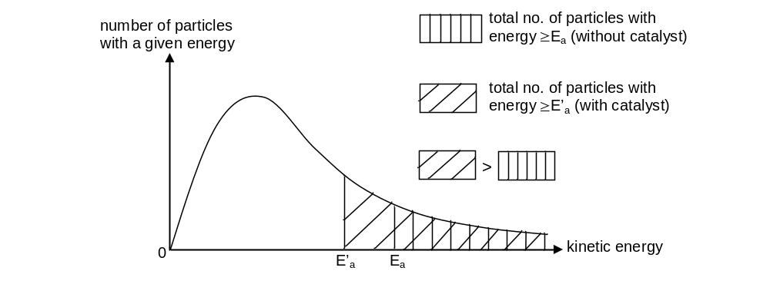
The mixture acts as a catalyst, which lowers the activaton energy and increases the proportion of molecules with sufficient energy to overcome the energy barrier upon collision/increases the proportion of molecules with energy greater and equal to activation energy. The frequency of effective collisions increases, and hence, the rate of reaction increases.

(a)(iv) At 1 atm, P_{NH3} = 4.40 x 10^{–3} atm
P_{N2} = 0.25 x (1 – 4.40 x 10^{–3}) = 0.249 atm
P_{H2} = 0.75 x (1 – 4.40 x 10^{–3}) = 0.746 atm
K_{p} = (4.40 x 10^{–3})² / (0.249)(0.746)³ = 1.87 x 10^{–4} atm^{–2}

(b)(i)

(b)(ii) M(OH)₂(s) → MO(s) + H₂O(g)
Down the group, the decomposition temperature of the metal hydroxide increases.
As the cationic radius of M²⁺ increases down the group, polarizing power decreases since charge density decreases.
The OH– electron cloud is polarized to a smaller extent and the O—H bond is distorted less, making it harder for the hydroxide to decompose.

(c)(i) Aqueous NaOH, heat
Product: CH₃CH₂COO–Na⁺

(c)(ii) 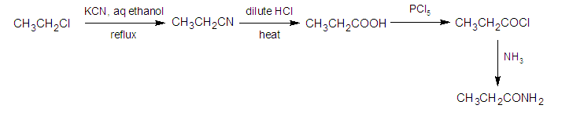

Question 5
(a)(i) Na, Mg and Al have high melting points due to the presence of strong metallic bonds / strong electrostatic forces of attraction between cations and the sea of delocalised valence electrons, whose strength increases from Na to Al as the number of valence electrons that can be donated into the ‘sea’ of delocalised electrons increases. Hence, increasingly large amounts of energy are required to overcome these metallic bonds.
Si has the highest melting point across the period due to the very strong covalent Si—Si bonds holding the giant molecule together. Hence, very large amount of energy is required to overcome the covalent bonds between the atoms.
P₄, S₈, Cl₂ and Ar exist as discrete molecules/atoms, held together by weak van der Waals’ forces. Hence, little eamounts of energy is required to overcome these bonds. Since the number of electrons decreases from S₈ > P₄ > Cl₂ > Ar, the electron cloud becomes less polarisable, hence the melting point decreases accordingly.

(a)(ii) Al³⁺ has a high charge density/high polarising power, and polarises water molecules to release H⁺. The [Al(H₂O)₆]³⁺ complex undergoes appreciable hydrolysis.
[Al(H₂O)₆]³⁺ + H₂O [Al(H₂O)₅(OH)]²⁺ + H₃O⁺
SiCl₄ undergoes hydrolysis with water to give HCl, which can dissolve in water to give an acidic solution.
SiCl₄(l) + 2H₂O(l) → SiO₂(s) + 4HCl(g)

(a)(iii) Aluminium oxide reacts with both acids and bases:
Al₂O₃(s) + 6H⁺(aq) → 2Al³⁺(aq) + 3H₂O(l) Al₂O₃(s) + 2OH–(aq)+ 3H₂O(l) → 2[Al(OH)₄]–(aq)
(b)(i)
Observation | Deduction
P undergoes oxidation with acidified K₂Cr₂O₇. | P contains functional groups that can be oxidised by K₂Cr₂O₇, e.g. alcohol.
Q reacts with carbonate in an acid-base reaction. | Q is a carboxylic acid → P contains a primary alcohol.
P and Q are oxidised by aqueous alkaline iodine to give iodoform/tri-iodomethane. | P contains –CH(CH₃)OH while Q is a methyl ketone.
Q reacts with NH₃ to give S in an acid-base reaction. | S is an ammonium carboxylate salt.

P = CH₃CH(OH)CH₂CH₂OH | Q = CH₃COCH₂COOH
R = CHI₃ | S = CH₃COCH₂COO–NH₄⁺

(b)(ii) For hydroxyl compounds, the acidity depends on the stability of the conjugate base. The more stable the conjugate base, the more acidic the hydroxyl compound.
P is an alcohol. The electron donating alkyl groups destabilises the alkoxide ion by intensifying the negative charge, hence reducing the acidity of the alcohol.
Q is a carboxylic acid. The carboxylate anion forms 2 equivalent resonance structures with delocalisation of the negative charge over 2 highly electronegative O atoms. This results in carboxylate anion being greatly stabilised, and its formation is energetically favoured.

(b)(iii) Heat evolved = – nΔH = mcΔT = (50)(4.18)(1.80) = 376.2 J
Amount of Q = m/M_{r} = 0.765/102.0 = 0.0075 mol
Amount of NaOH = 0.0100 mol (Q is limiting → Amount of water formed = 0.0075 mol)
Therefore, ΔH = – 0.3762 / 0.0075 = –50.2 kJ mol^{–1}
This value is less exothermic than the enthalpy change of neutralisation between a strong acid and a strong base (–57.3 kJ mol^{–1}), as Q is a weak acid and some energy is required to fully ionise it.

Paper 2 Answers

1 (a) Dilute sulfuric acid should not be used because the impervious layer of insoluble salt BaSO₄ forming around the barium sulfite could stop the reaction prematurely.

(b) SO₂ is highly soluble in water; gas collected will be less than expected.

(c)
graduated, frictionless gas syringe
Thistle funnel with 25 cm³ of 0.50 mol dm⁻³ dilute HCl.
Markings on thistle funnel allow 20 cm³ of the acid to be introduced.

250 cm³ conical flask

Barium sulfite

(d) Maximum volume of gas collected = 100 cm³
Amount of gas = 100/24000 mol = Amount of BaSO₃
Mass of BaSO₃ = 100/24000 x (137 + 32.1 + 3(16.0)) = 0.905 g

(e) List of measurements
- Weigh out accurately the mass of the barium sulfite to be 0.900 g.
[Record the total mass of weighing bottle and the sample, m₁.Transfer this into a 250 cm³ conical flask. Reweigh the emptied weighing bottle and record its mass m₂. The mass of barium sulfite sample used = m₁ − m₂]

- Measure the volume of acid used (ensure it is in excess) with appropriate equipment (e.g. pipette or burette or measuring cylinder) and record as V_{acid}.
[Suggest > 16.7 cm³ of 0.50 mol dm⁻³ dilute HCl into the thistle funnel if 0.905 g of BaSO₃ is used]

- Measure the maximum volume of gas collected by reading off the graduated gas syringe, indicating that the piston stops moving.
[Record V_{before} = volume reading before experiment, V_{after} = volume reading after experiment. 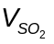= V_{after} − V_{before} (−V_{acid} if thistle funnel is used)]

- Record temperature and pressure reading of the collected gas at the end of the collection [using thermometer and barometer respectively]

(f) (i) SO₂ is not an ideal gas (since the molecules experience a greater intermolecular force of attractions or significant molecular volume) OR SO₂ is soluble in water.
(ii) The reaction of acid and metal will product H₂ gas. H₂ deviates less from ideal gas behaviour since the intermolecular forces of attraction between H₂ molecules are weaker than that between SO₂ molecules. OR H₂ is less soluble in water.

2 (a) sp³; sp

(b)
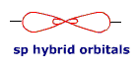
(c) C₂H₂ + NaNH₂ → Na⁺[C₂H]⁻ + NH₃ OR C₂H₂ + 2NaNH₂ → Na₂C₂+2NH₃

(d) CH₄ accepts a proton/H⁺ from HF−SbF₅

(e) The intermediate contains [CH₅]⁺ which is unstable due to steric repulsion OR the C contains 5 covalent bonds (pentavalent).

(f) trigonal planar; 120°; octahedral; 90°

(g) Gas A is CH₄ Positive ion is (CH₃)₃C⁺

3 (a) oxidation state of Fe in “super-iron” battery is +6, which is much higher than the common oxidation state of +2/+3 in Fe compounds.

(b) Anode: Zn(s) + 2OH⁻(aq) → Zn(OH)₂(s) + 2e⁻
Cathode: FeO₄²⁻(aq) + 4H₂O(l) + 3e⁻ → Fe(OH)₃(s) + 5OH⁻(aq)

(c) Amount of FeO₄²⁻ = 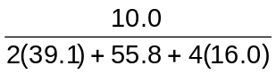= 0.0505 mol
Amount of e⁻ = 3(0.0505) mol
Q = 3(0.0505) 96500 = 1.46 x 10⁴ C

4 (a) At maximum buffer capacity,
Mol ratio of CH₃COOH : CH₃COO⁻Na⁺ = 1 : 1
From 3x to 8x of NaOH used, 5x of CH₃COOH is converted to CH₃COO⁻Na⁺
Hence at maximum buffer capacity CH₃COOH : CH₃COO⁻Na⁺ = 5x : 5x
Working backwards, at the beginning of titration,
mol ratio of CH₃COOH : CH₃COO⁻Na⁺ = 5x + 3x : 5x − 3x = 8x : 2x = 4:1
[CH₃COOH] : [CH₃COO⁻Na⁺] = 4:1

(b) pH = pK_{a} + lg 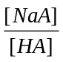
4.16 = pK_{a} + lg (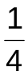)
pK_{a} = 4.76 Hence, K_{a} = 1.73 × 10⁻⁵ mol dm⁻³

5 (a) 1s² 2s² 2p⁶ 3s²3p⁶3d⁹

(b) Circle two N and four O⁻

(c) Amount of edta⁴⁻ = 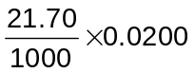= 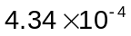mol = Amount of Cu
% mass of Cu = 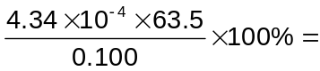27.6%

(d) (i) Ag⁺ + Cl⁻ → AgCl;
(ii) Amount of Ag⁺ = 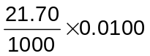= 2.17x10⁻³ = Amount of Cl⁻
% mass of Cl = 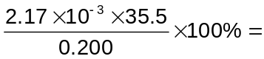38.5%

(e) At beginning of titration: white ppt (in green/blue solution)
At end point: red ppt;

(f) Method 1: When all AgCl is precipitated, [Ag⁺] = 1.42 x 10⁻⁵ mol dm⁻³
At this point, [Ag⁺]²[CrO₄²⁻] = (1.42 x 10⁻⁵)² x 0.01 = 2.02 x 10⁻¹²
which is just less than K_{sp} for Ag₂CrO₄ (3.01 x 10⁻¹²)

Method 2:
[Ag⁺] when Ag₂CrO₄ starts to precipitate = 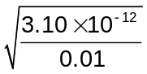 = 1.73x10⁻⁵ mol dm⁻³
[Cl⁻] when Ag₂CrO₄ starts to precipitate = 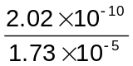 = 1.16x10⁻⁵ mol dm⁻³. This value is very small, hence most of AgCl would have precipitated out by the time Ag₂CrO₄ starts to precipitate out.

(g) % mass of O = [100 − (20.87 + 5.17 + 5.96 + 27.6 + 38.5)] % = 1.90%

(h) Oxygen

(i) Since ratio Cu:Cl:C:H:N = 2:5:8:24:2;
Cation is (CH₃)₄N⁺ so there must be two of this cation per empirical formula of B and the anion must then carry a charge of 2−
Let empirical formula of anion be [Cu₂Cl₅O_{n} ]²⁻;
Judging from the oxidation states of Cu (+2) and Cl (−1), n = 0.5
Hence the molecular formula of the negative ion of B is [Cu₄Cl₁₀O]⁴⁻

(j) [Cu(H₂O)₆]²⁺(aq) + 2OH⁻(aq) → Cu(OH)₂(s) + 6H₂O(l);
or [Cu(H₂O)₆]²⁺(aq) + 2OH⁻(aq) → [Cu(OH)₂(H₂O)₄](s) + 2H₂O(l)

Cu(OH)₂(s) + 4NH₃ → [Cu(NH₃)₄]²⁺(aq) + 2OH⁻(aq);
or [Cu(OH)₂(H₂O)₄] + 4NH₃ → [Cu(NH₃)₄(H₂O)₂]²⁺(aq) + 2OH⁻ + 2H₂O

(k) ∆S > 0
∆n > 0; there is an increase in number of moles of compounds, leading to greater disorder or higher randomness

(l) −T∆S <0; ∆G = ∆H − T∆S < 0 for all T

6 (a) (i) Step I: cold concentrated H₂SO₄, followed by H₂O, warm
Step II: KMnO₄, H₂SO₄(aq), heat

(ii) Compound D:
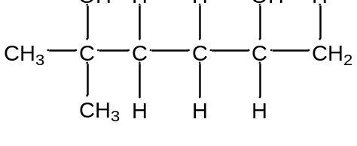

Compound F:
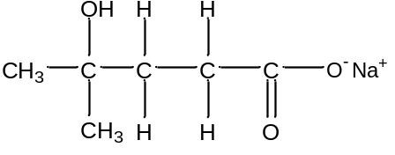 OR 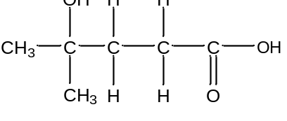

(b) (i)
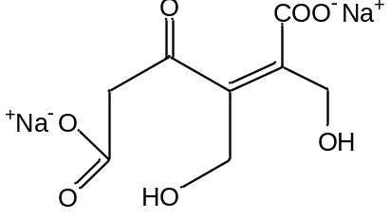

(ii)
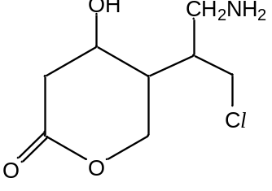

7 (a) CH₃NH₂ is more basic than ammonia due to the presence of an electron-donating methyl group which increases the availability of the lone pair of electrons on N for protonation.

CH₃NH₂ is less basic than (CH₃)₂NH since (CH₃)₂NH has two electron-donating methyl groups which makes the lone pair of electrons on N even more available for protonation.

(b) P is CH₃CH₂CH₂I
Q is (CH₃)₂N(CH₂CH₂CH₃)

(c) (i) Elimination
(ii) R, S, T respectively:

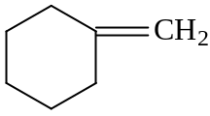;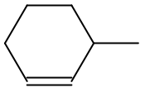 ;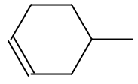

Paper 1 Answers

BDAAD BBCBA BCDAB CCDCB ABAAC DCBDA BBBDA BCDBC

